Program












The NYC Otaku Choir
Summer 2026

Soprano
Amanda
Felicity Audet
Elaine C.
Sophia Chan
Arya Chandra
Melanie Chin
Heather Huang
Jasmine Jenkins
Joanna Ju
Silvia Martinez
Ashley Mendez
Sophie Mori
Miffy Musngi
Inez Nelson
Delaney R. Page
eris prado
Midori Sano
Angi Suwoto
Cherry Xu
Annie Y

Alto
Rahanna Brown
Kelly Burrus
Harmony Chau
Morgani Aiyana Elam
Mia Harada
Diana Hernandez
Allison “Illy” Huang
Kyla Hunter
Jibi Jacob
Erica Klein-Meisenhelter
Mente
Yulin Ni
Onyx
Ariana Osmanzai
Jalisha Paz
Eiji Ren
Ash Toner
Amanda Waldron
Alice Q Wong

Tenor
Connor "Bear" Barre
Jiahao Chen
Ethan Ferrall
Johnathan Gibbs
James Huang
Frederick Li
Nathan Li
Abraham Rogers Lopez
Shiana M
Patty Mahaney
Anthony Merolla
Jourdan Ooi
Nina Pankova
Joshua Pyram
Christopher Smith
Justin Sun
Randolph Tan
Ivan Wang
Erin-Marquise Watson

Bass
Injung Ahn
Chomp
Quinn Ferguson
Pablo Giraldo
Sadinah Gueye
Pierce Lai
Richard Lu
Andrew McGowan
Joel Verez Mora
Dante Rose
Evan Rosson
Sebastián Villamizar Santamaría
Geoffrey Shlapak
Michael Steigman
Ko Tanaka
Jason Wang

Accompanist  James Brandfonbrener  Lulu Chen (Cover) | Co-Conductors  Joanna Ju  Ko Tanaka | Artistic Director  Johnathan Gibbs

DIRECTOR OF OPERATIONS
Mente

VOLUNTEERS
Calise Jin  Gordon Wang  Natt Hong  Kalif Terrell Mayers | Quyen Hoang  Junming Qiu  Yanne Veloz  Judy Wu | Steven Liu  Jibi J, Kara Lui  Samuel Calto  Dorothy Lee
Thank you for joining us tonight at The DiMenna Center for Classical Music as we present Otaku Oratorio 2: I Set Out to Save the World, but It Turns Out the World’s Greatest Threat Is a Kid Who Calls Me Mom. The Otaku Choir has been working hard to make tonight’s show a reality. We’ve leveled up since last year, too! This year, we are introducing hand-drawn sprites, animated within the Ren’Py engine. We have also added sound cues and effects, much different than last year, which only featured background music. Finally, our story has evolved from a narrated script to a full-fledged and voice acted spectacle. Last year we premiered the Otaku Oratorio with an Isekai story. This year we present a Space Saga. It is our hope that you will return next year as we present our third Otaku Oratorio that will explore the Magical Girl genre. Thank you, again, for being here with us.

Act 1  Fumetsu no Hero 不滅のヒーロー  Masaaki Endo  Arr. Ko Tanaka  Butter-Fly  Hidenori Chiwata  Arr. Richard Lu  Hana ni Natte 花になって  Shingo Anami  Arr. Kohsuke Negishi  Moonlight Densetsu ムーンライト伝説  Tetsuya Komoro  Arr. Yulin Ni  Shanghai Tan 上海灘  Joseph Koo  Arr. Cherie Chai  Lilium  Kayo Konishi & Yukio Kondo  Arr. Anthony Merolla  Weight of the World  Keiichi Okabe  Arr. Sophia Chan  Ragnarok  Masashi Hamauzu  Arr. MostlyMiSinging | Act 2  The Final Day 終焉の戦い  Masayoshi Soken  Arr. Andrew McGowan & Geoffery Shlapak  Silhouette シルエット  Maguro Taniguchi  Arr. Ko Tanaka  Soto 外  Hakushi Hasegawa  Arr. Ko Tanaka  Floating Moon on the Water 水面月影  Wei-Pin Chen  Arr. Eric Liu  Baka Mitai ばかみたい  Mitsuharu Fukuyama  Arr. Yulin Ni  Destati  Yoko Shimomura  Arr. Joel Scianna  Super Smash Bros. Brawl Opening メインテーマ  Nobuo Uematsu  Arr. ZaneChihuahua  Welcome to the New World  Tadashi Ikegami  Arr. Ethan Ferrall
OTAKU ORATORIO 2
I Set Out to Save the World, but It Turns Out the World’s Greatest Threat Is a Kid Who Calls Me Mom.

WRITER Johnathan Gibbs DIRECTOR Danny
ASSISTANT DIRECTOR  Silvia | ADDITIONAL WRITING/ CONSULTATION  Christopher Evangelista, Danny, Kelly Burrus | USAGI KITADANI  Sophia Chan
GEORGE SANDERS  Chomp | TAKESHI WILLIAMSON  Geoffrey Shlapak | THE CHILD, COMPUTER VOICE  Jalisha Paz
KOHEI KITADANI  Erin-Marquise Watson | LINDA KITADANI  Rahanna Brown | GUNNER CHIEF  Allison “Illy” Huang
PROFESSOR KELISHA  Ashley Foster  NEWS REPORTER #2 • GOSSIPING STUDENT #2  Ashley Mendez | NEWS REPORTER #1 • GOSSIPING STUDENT #1 • TRAIN SECURITY GUARD • FIRST OFFICER  Felicity Audet | NAVIGATION CHIEF • NEWS REPORTER #3 • GOSSIPING STUDENT #3  Eiji Ren
QUEEN ELIZABETH NEWARK  Ariana Osmanzai  BARTHOLEMEW BARTHANDELUS  Connor “Bear” Barre | JOSEPH “JOJO” CHEN  Abraham “AJ” Lopez | PROFESSOR WELLINGTON  Delaney R. Page
ELITE GENERAL ROBERT HUXTABLE  Pablo Giraldo | SABIK THE GREAT RESETTER  Nina Pankova | BGM MUSIC SUPERVISOR  Nathan Li
BGM ASSISTANT SUPERVISOR  Abraham “AJ” Lopez | SOUND EFFECT SUPERVISORS  Ko Tanaka • Nathan Li | VISUAL NOVEL OPERATOR  Kyle Navarro
VISUAL NOVEL ENGINEER / ANIMATOR  Evan Rosson | LOGO DESIGN  Abraham “AJ” Lopez | MANGA PANELIST  Alice, Miffy
EYECATCHES  Miffy, AJ, Shiana | SCENE ARTIST  Elaine, Connor “Bear” Barre, Miffy | CHARACTER SPRITE ARTIST  Pierce
SOUND MIXING  Nadeem | MECH SPRITE ARTIST  AJ, Shiana, Elaine, Pierce | COSTUMING  Ariana Osmanzai • Erica Klein-Meisenhelter


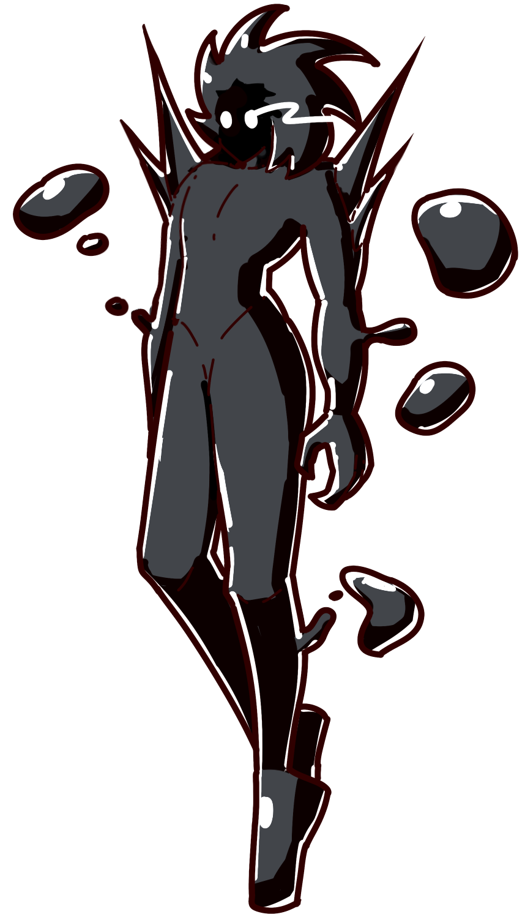

No generative AI was used to create this show.

Insert
👑 THE CROWN RECORD 👑
THE OFFICIAL PAPER OF THE STABILIZED DEMOCRACY

HUMANITY REMEMBERS CAPTAIN KOHEI KITADANI
Sixteen Years Since the Hero of Eden Gave His Life for Our Future


Captain Kohei Kitadani, decorated officer of the Earth Crown Military, geological scientist and father of the Ultima Cannon, is remembered today on the sixteenth anniversary of the Eden Incident.

Sixteen years ago, Captain Kitadani led the Eden into humanity’s darkest hour. Facing the Planet Destroyer, the alien terror that had already brought devastation to Earth, Kitadani made the ultimate sacrifice. The Ultima Cannon struck its target and the threat was neutralized.
Crown historians credit Kitadani’s final action with ending the immediate threat and beginning the longest period of planetary stability since the Cataclysm. His name has since become synonymous with service, readiness and sacrifice.  He left behind his wife, Linda, and daughter, Usagi. Today, Cadet Usagi Kitadani continues her father’s proud tradition of service at the Crown Military Academy. | His courage gave humanity sixteen years of peace. His legacy reminds us that survival is never guaranteed. It is protected.  Across the Stabilized Democracy, memorial observances today honor the officers and crew of the Eden and the sacrifice that secured humanity’s future.  THE CROWN REMEMBERS. HUMANITY ENDURES. FOR THE GREATER GOOD!

ULTIMA KEEPS TOMORROW BRIGHT  Power. Transit. Planetary defense. Ultima keeps civilization moving.  ENERGY • SECURITY • CONTINUITY  Contact: Dr. Joseph Chen. | ACADEMY APPLICATIONS NOW OPEN  ACE • SUPPORT • AUXILIARY  Train with advanced mechs. Serve where humanity needs you.  SERVICE IS HONOR. • Contact: Prof. Kelisha Alvarez
NEW JERSEY SUPPLY DISRUPTION: DAY 42  Unauthorized work stoppage continues to affect Ultima production. Rely on verified Crown Network reports. — Contact Gen. Robert Huxtable | KNOW YOUR DOME  Atmospheric stabilizers protect millions. Report seal warnings or unauthorized exterior access.  YOUR DOME. YOUR SAFETY. • Prof. Wellington.
EXTRA FAST TRAVEL SEAT  Crown-certified fast travel to approved Earth gates. Clearance required. Friend bailed on me after we got into an argument about lunars. • Contact @GSanders2. | KITADANI COMMEMORATIVE EDITION  Thank you to The Crown, The King and to Crown Network for continuing to honor my husband’s sacrifice • Contact Linda Kitadani.
SEASON FINALE  I Got Hit By A Bus and now my Love Triangle of Friends are RPG Heroes, airing season finale this Friday night!  Will they summon the bus? What will happen to the pirate cats!? Tune in to find out! | CROWN NETWORK NEWS  NEWS YOU CAN TRUST  Official alerts, regional notices and verified information.  TRUST VERIFIED SOURCES. PROTECT THE TRUTH.

🌚 THE CRATER UNDERGROUND ✊
INDEPENDENT NEWS FOR EARTH-BORN, COLONY-BORN AND EVERYONE THE CROWN WOULD RATHER KEEP APART

THE UNDERGROUND MARKET  BUY • SELL • TRADE • REPAIR  Pressure seals • mech parts • film • Earth imports • corrected academy books • old Crown receivers • decorative dome filters  NO ULTIMA ORE. NO QUESTIONS. • @moonrabbit_16 | PERSONALS & MISSED CONNECTIONS  EARTH-BORN, 24, seeks colony-born person who thinks two hours on a train is “basically nearby.” Must enjoy parfaits. No Crown officers. • Contact @ace_of_earth  FOUND: academy ID near Rush Crater station. •  Contact @support_unit
NEW JERSEY RELOCATION PARTY  The Crown is trippin HARD you all… We have to bounce from this thang like a dodge ball off Robert Huxtable’s face.  Make sure to tune in to Otaku Airwaves at 1900 hours this Friday 10/9 for directions.  Remember the Kingdom of New Jersey. Remember who wrote the report. • Contact: @Da_Kween67 | ULTIMA: WHO PAYS FOR YOUR POWER?  Ultima ore comes out of the Earth. The Crown controls the mines, the research and the weapons built from it. When workers in New Jersey refused extraction orders, the Crown called their resistance a threat to “continuity.”  Ask where your power comes from. Ask who had to obey for you to have it.
COMMUNITY NOTICE  COLONY-BORN IS NOT A RANK.  “Lunar” when they insult you. “Strategically vital” when they need you. We live here. We belong here. • @support_unit | CROWN LISTENING IN ON YOUR HOLO-TIME CALLS?  Worried about privacy issues? Trying to download the latest episodes of I Got Hit by a Bus? Use MORD VPN to stay safe online! Contact @MORD-VPN
CABBAGES! AGAIN!  REWARD OFFERED  To the bald headed rascal destroying my stand:  I KNOW YOU ARE OUT THERE.  Fresh Earth-grown cabbages. One-crate reward for the culprit. • Contact @CROWN_CABBAGES_PRODUCE | Absolute Pho-nema  YES, IT IS WORTH THE TRAIN RIDE.  Hot broth. Big bowls. Open late. Rush Crater Transit District. “If your friend says they don’t give a pho, bring them anyway.” •  Contact @PhoNemaRushCrater
EDEN WRECKAGE SALE  Obtained some mech parts, gears, plating and other doohickeys from a newly discovered crash site. Will trade for passage to Earth. No questions.  Contact @Resistance04 | CLASSIFIEDS: EARTHBOUND  Last-minute Earth passage wanted. Any North American gate. Will trade credits, film or meal vouchers. No questions. • @support_unit / Box 206
LOST & FOUND  LOST: Academy ID lost on Rush Crater bound train Platform at Academy station. Contact @TKW100  FOUND: Hoping to find the owner, Fast Travel Voucher to Bakersfield Dome. Very expensive. DM me the name and it’s yours. Contact @LHud01Ace | KOHEI KITADANI: HERO... OR CONVENIENT STORY?  Every year: the same memorial, the same hero, the same Crown-approved ending. Why were Eden’s communications jammed? Why are records still sealed?  Kitadani died on Eden. Everything around it deserves another look.  WHAT ARE THEY HIDING? • @quiet_professor
FOR SALE: ONE PERFECTLY GOOD PARFAIT  Barely touched because SOMEONE chose dessert to discuss planetary exploitation.  Strawberry intact. Spoon included. • @moonrabbit_16  FOR SALE: TOP QUALITY ULTIMA ORE HALF PRICE  Picked up a few crates from a Crown Warehouse, redistributing to anyone who needs it for their everyday life.  Contact @Support-Unit  FOR SALE: CABBAGES FROM EARTH  Fresh cabbages. Need Ultima ore for our Earth transport. No questions asked. | PUBLIC NOTICE: YOUR DOME IS NOT SAVING YOU  If the air outside kills us, why were New Jersey miners standing in it? Open a window. Ask a question. Try not to get arrested.  PUBLIC NOTICE: THE END IS NEAR  Young people we are living in THE END OF DAYS! The Great Resetter is AMONG US! LIVING IN THE SHADOWS  COMMUNITY NOTICE:STAND UP TO PLANETISM  Do NOT let these Earth Borns run you over! STAND UP FOR YOURSELF. WE built these colonies THEY are visitors, period.

